Practical: Create a CloudWatch alarm which goes off to an Alarm state when the CPU utilization of an EC2 instance goes above 65%. Also add an SNS topic so that it notifies the person when the threshold is crossed.
Step 1: Firstly create 1 EC2 instance.
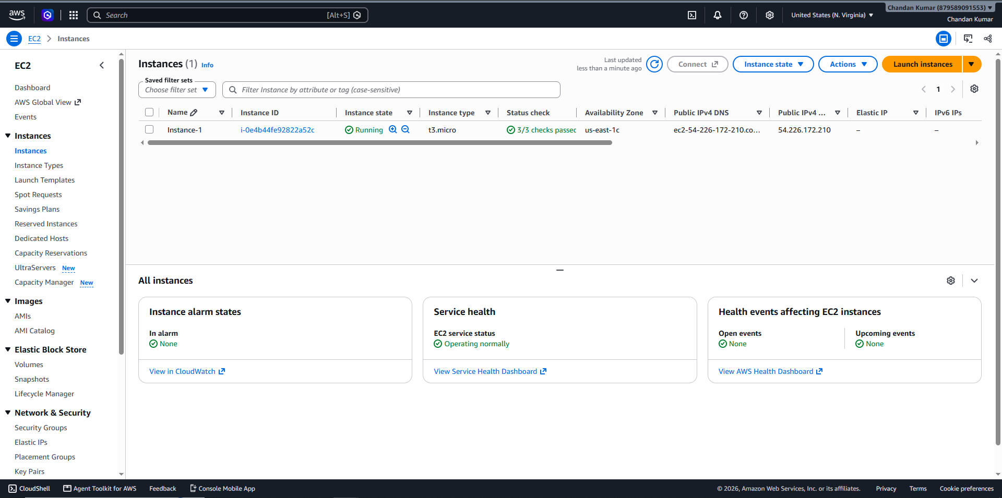
Step 2: Search Cloud Watch > Under Alarms > Click on create alarms > Specify metric and conditions > Data source = Metrics > Type = Classic > Metric = Select Metric. > Click on select Metric.
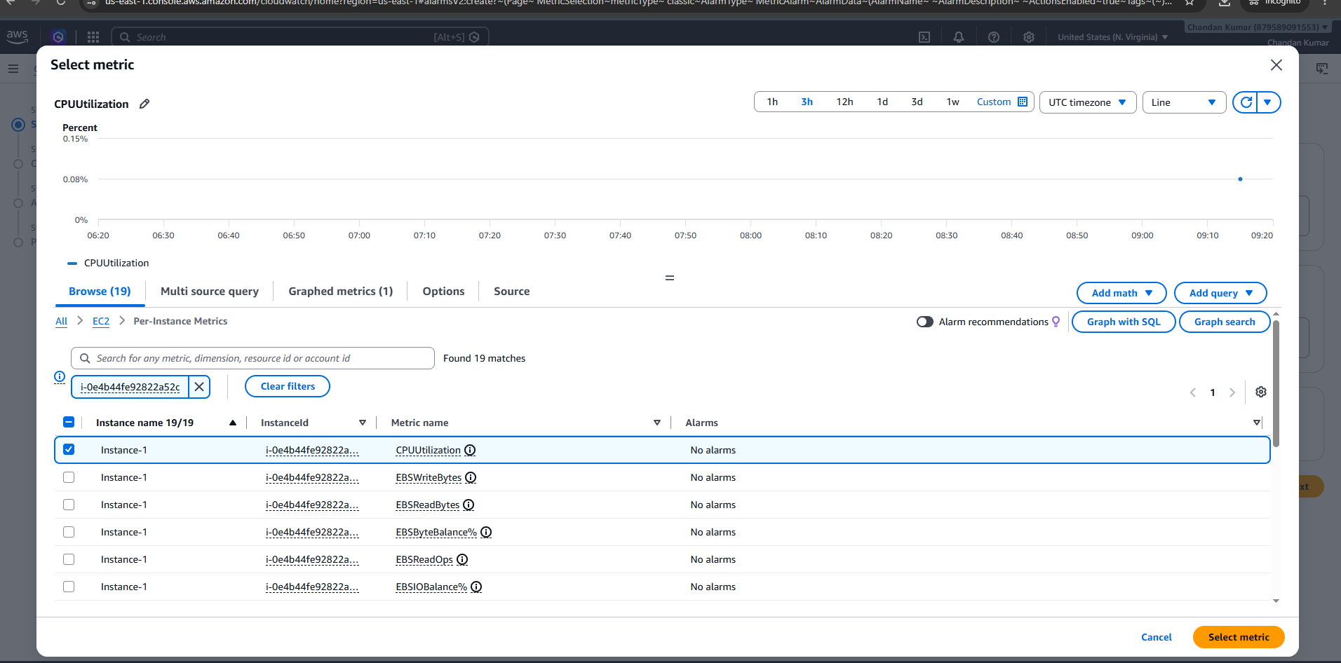
Step 3: Threshold type = Static > Whenever CPUUtilization is... = Greater/Equal > than = 65 > Click on Next.
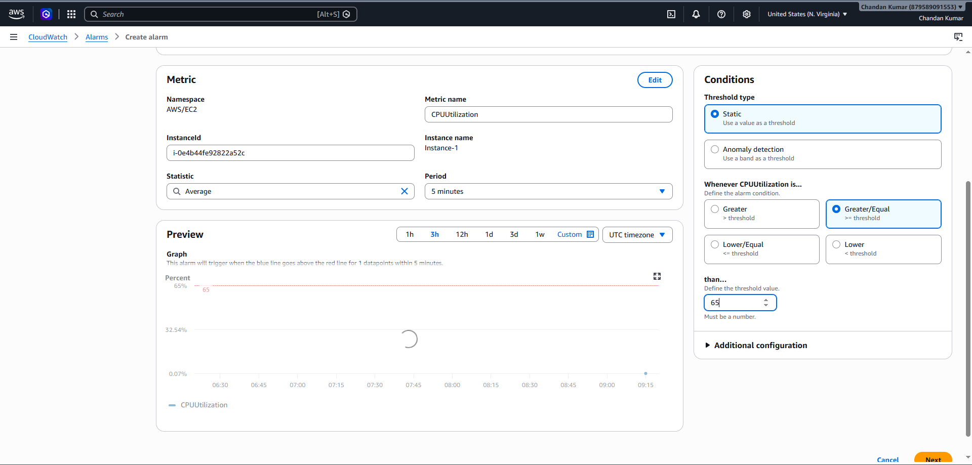
Step 4: Under Configure actions > Alarm state trigger = In Alarm > Send a notification to the following SNS topic = Create new topic > Send a notification to… = ankitrawat8447419614@gmail.com >
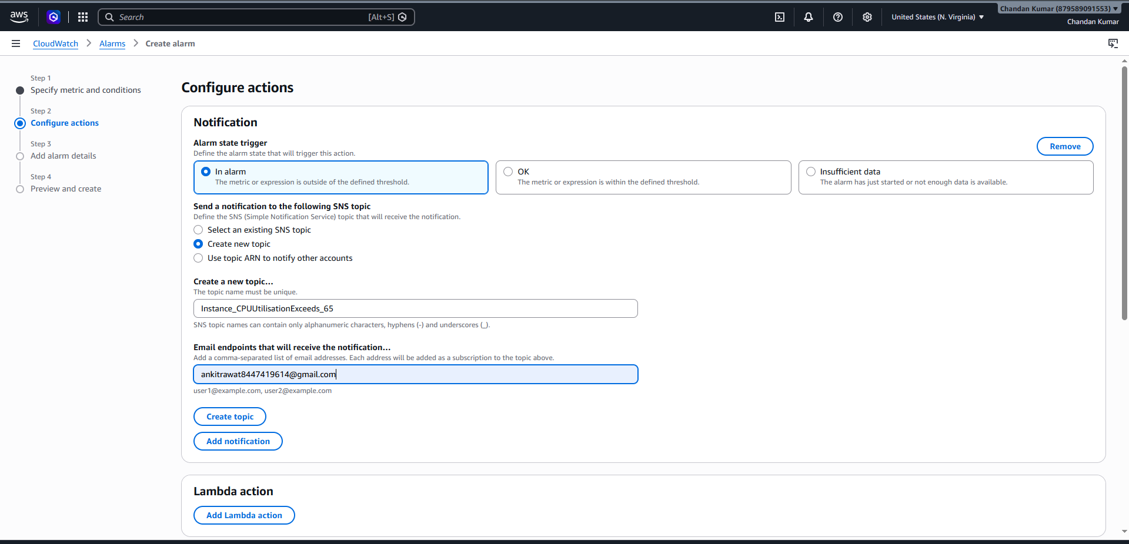
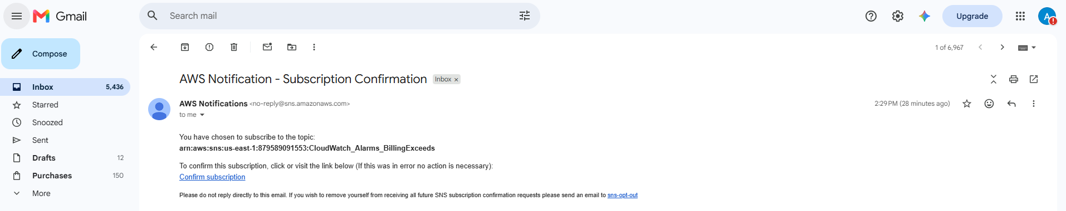
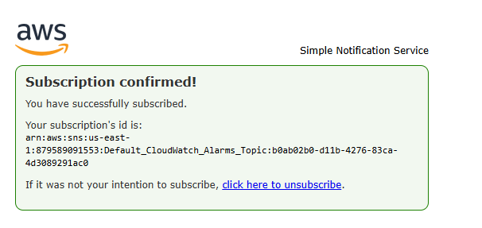
Step 5: Fill Add alarm details
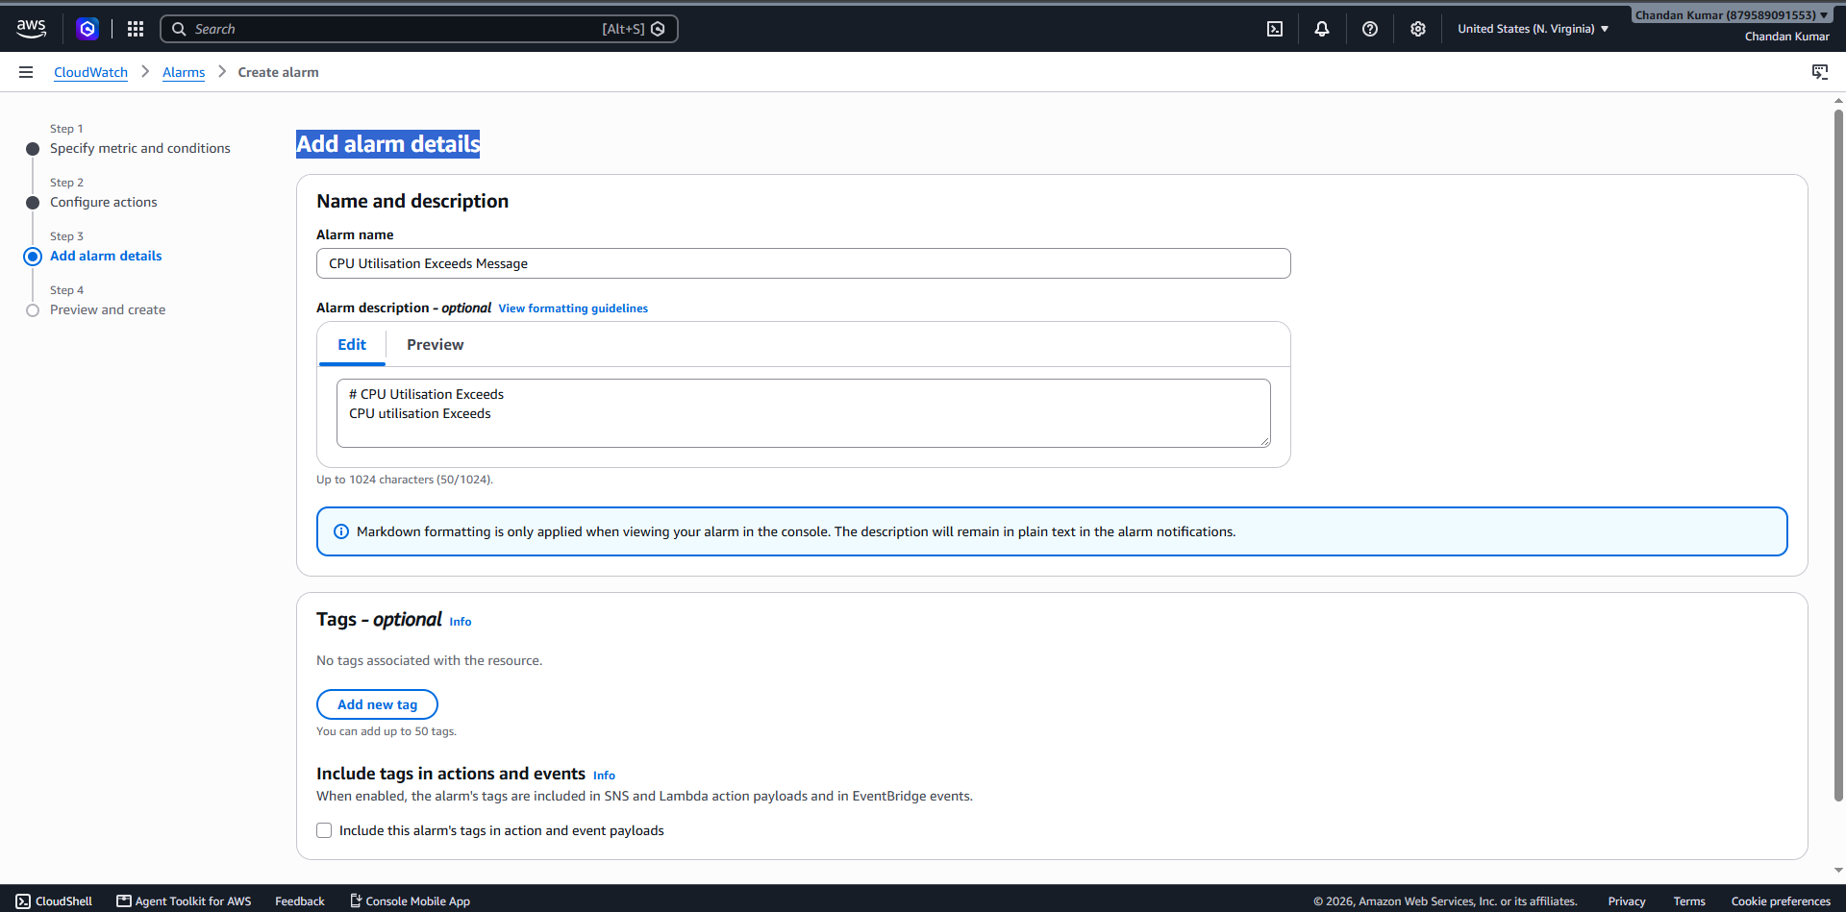
Step 6: Click on create Alarm.


